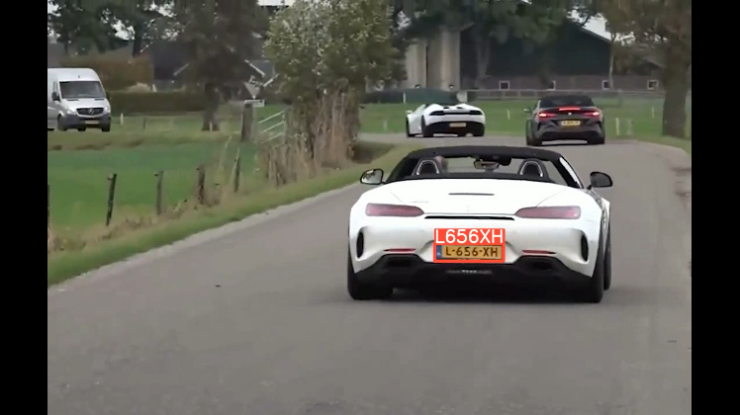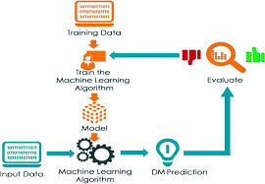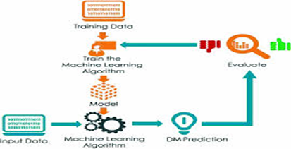

**Applications**

In this project, we have implemented a comprehensive vehicle detection system that integrates YOLOv8 for high-precision object detection, DeepSORT for robust multi-object tracking, and EasyOCR for accurate number plate recognition. The primary applications of this system include enhancing traffic monitoring and management by tracking traffic flow and detecting violations.

**Conclusion**

In this study, various machine learning algorithms were applied to the dataset, and classification was performed using different models. By integrating YOLOv8, DeepSORT, and EasyOCR, we have developed a robust and efficient system for real-time vehicle detection, tracking, and recognition, offering a substantial advancement in traffic management and surveillance applications.

Vehicle detection and recognition play a critical role in various applications such as traffic monitoring, security, and urban planning. Effective vehicle detection can significantly improve traffic management and law enforcement by providing real-time data and insights. Traditional methods often struggle with accuracy and efficiency, particularly in dynamic environments with multiple moving objects. In this project, we propose a comprehensive vehicle detection system utilizing YOLOv8 for object detection, DeepSORT for multi-object tracking, and EasyOCR for number plate recognition. Our system captures input video sequences and processes them to accurately detect, track, and recognize vehicles. By integrating YOLOv8's advanced detection capabilities with DeepSORT's robust tracking algorithm and EasyOCR's powerful text recognition, we achieve high accuracy and reliability in vehicle identification and tracking. This approach enhances the precision of vehicle detection and number plate recognition, providing a robust solution for modern traffic management and surveillance systems.

**Abstract**

**System Design & Implementation**

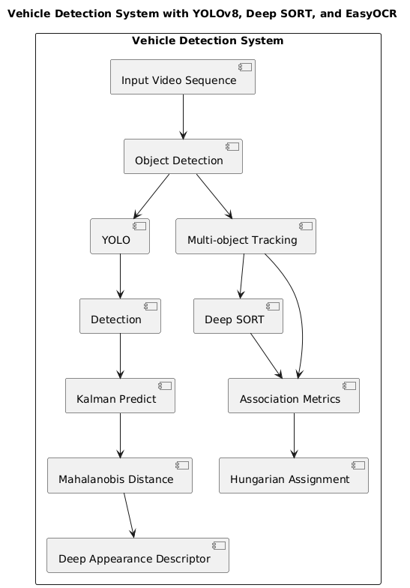

**Expected Result**

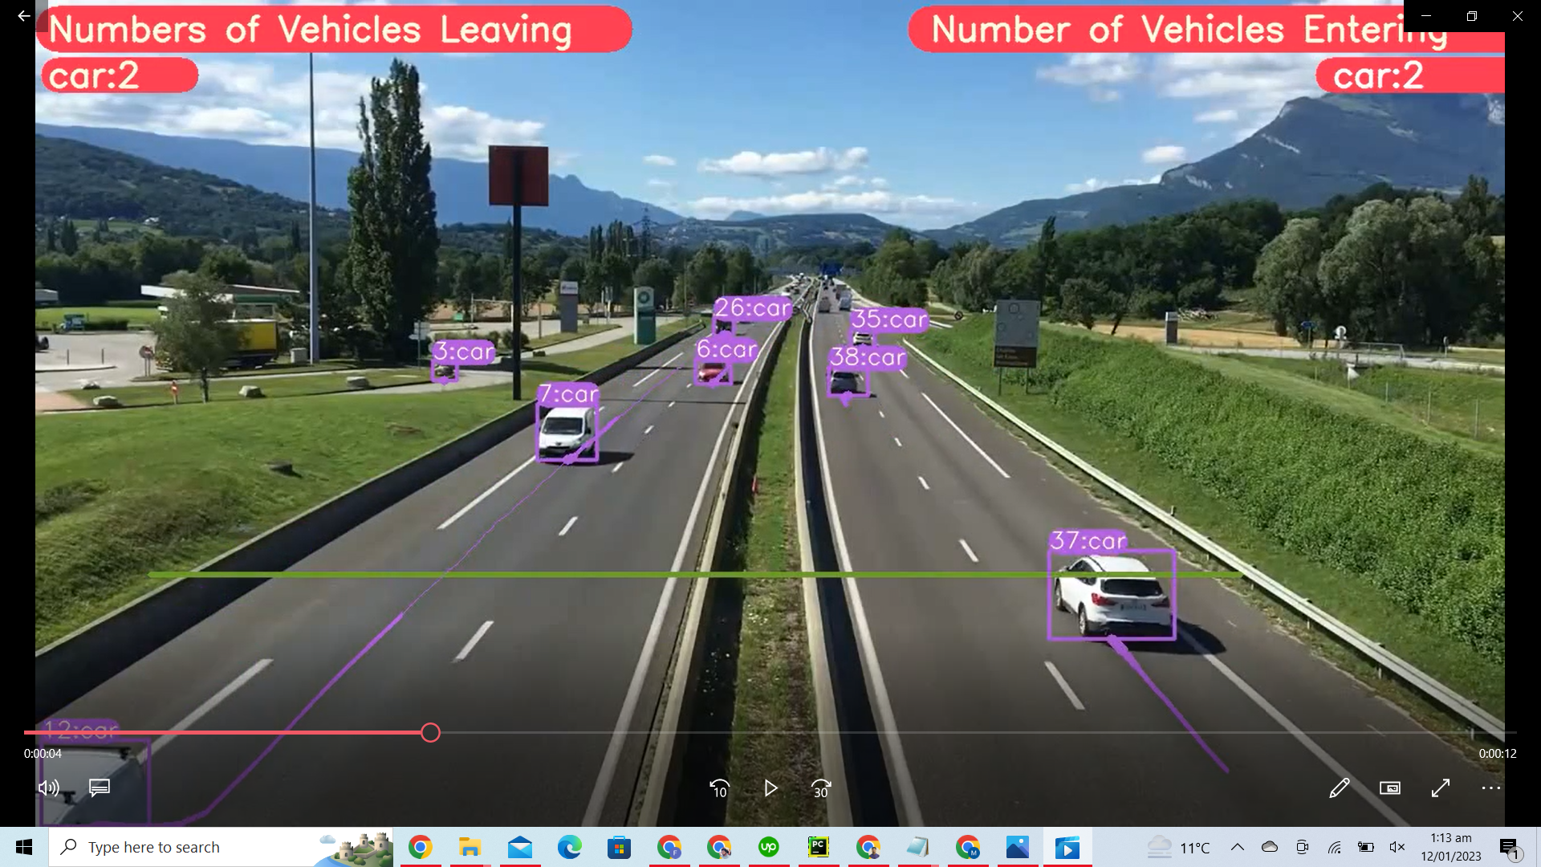

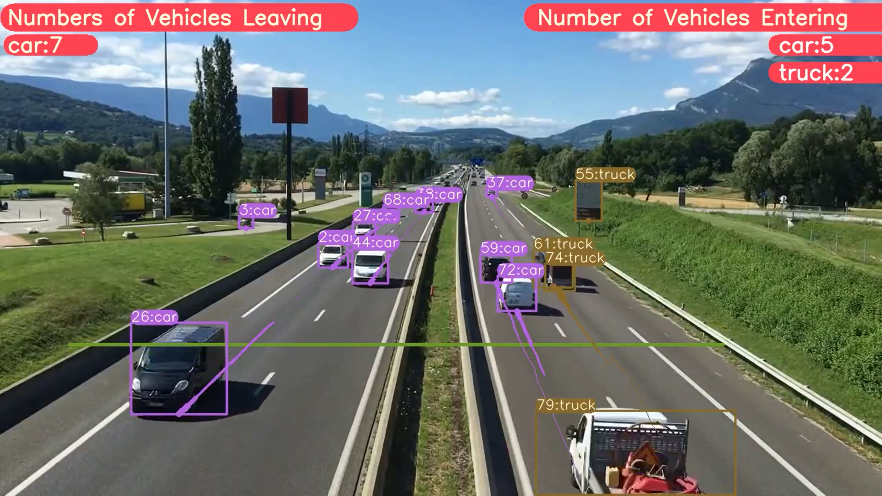

**Applications & Conclusion**

**Vehicle & Number Plate Detection Using YOLOv8 & EasyOCR**

**Team Members:**

**Pritish Ali [1EP21CS076]**

**Rupam Bhattacharyya [1EP21CS089]**

**Swati S [1EP21CS109]**

**Sushmita S [1EP21CS108]**

**Guide Name:**

**Prof. Manimegalai A**

**Problem Statement**

Traditional vehicle detection and tracking methods struggle with accuracy and efficiency in dynamic environments, posing challenges for traffic management and surveillance. This project aims to develop a comprehensive system using YOLOv8, DeepSORT, and EasyOCR to address these issues.

**Objectives**

Develop a high-precision vehicle detection and tracking system using YOLOv8, DeepSORT, and EasyOCR. Enhance the accuracy and efficiency of real-time vehicle detection, tracking, and number plate recognition for improved traffic management and surveillance.

**Tools used:**

**•** YOLOv8: For object detection.

• DeepSORT: For multi-object tracking.

• EasyOCR: For number plate recognition.

• OpenCV: For image processing.

**Results and Analysis**